**Hong Kong Institute of Vocational Education (LWL)**

**Department of Information and Communications Technology**

**Final Year Project (ITP4913M)**

**Initial Report**

**(2019/2020)**

**Automated Data Collecting System for Environment Using UAVs and Smartphones**

|  |  |
| --- | --- |
| Supervisor: | Edward Ma |
|  |  |

We declare that this is a group project and that no part of this submission has been copied from any other student’s work or from any other source except where due acknowledgement is made explicitly in the text, nor has any part been written for us by another person.

|  |  |  |  |
| --- | --- | --- | --- |
| **Student** | **Student No.** | **Contribution to the project (%)**  **(Total 100%)** | **Signature** |
| Wong Ming Yuen | 180275359 | 25% |  |
| Siu Chi Wang | 180042945 | 25% |  |
| Kwok Tsz Lung | 180047074 | 25% |  |
| Chau Yat Sum | 180478187 | 25% |  |

Table of Content

Abstract 4

Introduction 5

The Problems 6

Background 6

Problem Description 6

Problem Environment 6

Users of Completed System 6

Proposed Solution 7

The way of UAV and smartphone to communication 7

The way of UAV and notebook computer to communication 7

The structure of the mobile application 8

The function of the mobile application 8

Display real-time view from UAV 8

Control UAV 9

View UAV status information 9

Take photo or video 9

The structure of the Windows application 9

The function of the Windows application 9

Build up new mission 9

View mission 9

Data collection 9

Display real-time view from UAV 10

The inspection sensor of the drone 10

How to make users easily to use our system 11

Project Scope 11

Constraints 11

Wi-Fi stability problem 11

Battery capacity limitation 11

Fire risk with the LiPo battery 11

Weather problem 12

Hong Kong Drone Regulations 12

Hardware Facility 14

Drone 14

Client 15

Software Process Model 16

Project Plan 16

Staffing & Responsibilities 16

UML Diagrams 17

Actor Descriptions – Mobile App 17

Initial Use Case Descriptions – Mobile App 18

Refined Use Case Diagram – Mobile App 20

Refined Use Case Descriptions – Mobile App 21

Initial Use Case Diagram – Windows App 26

Actor Descriptions – Windows App 26

Initial Use Case Descriptions – Windows App 27

Refined Use Case Diagram – Windows App 28

Refined Use Case Descriptions – Windows App 29

Reference 34

# Abstract

This project is a competition project that we need to develop a Data Collection System. Our system will help the meteorologists to measure the weather, providing easy deploy instruments and performing weather analysis. Nowadays, smart devices are becoming much popular like Apple iPhone, iPad, Google Android devices...etc. The controller side aims at using mobile application by receiving the data from drone to analysis the weather.

In the world up to now there is not any standard Personal Drone System for weather analyzing. This system finally brings simplicity, ease of use to users in small and specific area and is environmentally friendly together with a mobile device and a drone.

Introduction

Unmanned Aerial Vehicle (UAV) become more universal and mature in the modern society. The UAV is widely used for different fields including rescue operation, military affairs and physical distribution. For personal use, the UAV is mainly for high-altitude aerial photography. Some safety guideline and the legal is made for flying UAV by Hong Kong government. Because of the mature technology of UAV and social environment, we based on the UAV to develop an Automated Data Collecting System to user for environment data collection.

This project aims to build up a client-side application. The system build-up a communication between UAV and devices which include smartphone and computer. The UAV can transfer the real-time view and collected data to the devices. Also, the UAV can execute the instruction from the devices. Users can collect the climatic data easily from the high altitude through this system.

All collected data should be belonged to a mission which is users created before these data is collected. These data are not sent out from the device. The only aim of all collected data is for users' study. Also, these data are protected in users' device.

This system we expect that the system can suits professional environment analyst and normal user at the same time. we make the system become more user-friendly. Also, the system can meet the requirement of the environment data collection for professional users because the system can collect and display detailed environment data by specific UAV.

In this report, we will introduce the system design which describes how the UAV and devices communication to achieve live stream and data collection functions. Also, we consider the proposed solutions for hardware and software, the system's constraints and related regulation about UAV. In addition, we have to make the project plan to arrange the time to make sure that the system can be completed on time.

# The Problems

## Background

As we know, nowadays, the environmental issue is increasingly severed. There is more and more exhaust emission because of industry high-speed development. This harm to personal health and the earth. So, people are highly worried about the environmental issue. A new environment data collecting system is expected. Our UAV could help people to collect climatic data accurately.

## Problem Description

Since the observatory cannot provide accurate data for every region. People can't get environmental data on a specific area.

First, the current climatic data collection tools normally work in the ground. The climatic analysis team can't collect climatic data from the sky. Many exhausts transmit to high altitude or exist in there. Therefore, the climatic analysis team can't get the most accurate data from the ground through the current data collection tool.

Second, someplace human can't arrive there easily such as disaster area and mountain. The climatic analysis team can't get the most accurate data from there. This will hinder some rescue operations or some researches.

Third, the current climatic data tools may not include data recording function. The analysts must use another tool to record the climatic data manually. After collection, they also need to analyze these data record. This will increase the working process of climatic data analysis.

## Problem Environment

The data analysts are lack of electronic technology and information technology to create a new environment data collecting system. They can use the current climatic data tool only. Nowadays, the environmental issue is increasingly severed. A new environment data collecting system can help them to be more convenient and accurate to collect climatic data.

# Users of Completed System

Our data collecting system is designed for user who want to have a mobile inspection tool. As we know that the quadcopter is a great platform for mobile use, user can deploy the device quickly and easily.

# Proposed Solution

This section is the discussion of solutions proposed to handle the problems encountered based on the design of the system, functionality and feasibility and the system requirements. Different aspects of problems have been concerned in terms of software and hardware layer. The discussed issues are as following:

* The way of UAV and smartphone to communication
* The way of UAV and notebook computer to communication
* The structure of the mobile application
* The function of the mobile application
* The structure of the Windows application
* The function of the Windows application
* The inspection sensor of the drone

## The way of UAV and smartphone to communication

Assume that the mobile application is installed to users' smartphone. The users will see the main page showing "no connection" when they open the mobile application. They should turn on the UAV and connect the smartphone to the Wi-Fi network of the UAVs. When the UAV and the smartphone are connected, the UAV will send the real-time view which is collected by the camera to the smartphone. The main page of the application will display the real-time view from the UAV when the users open the mobile application again. Also, the users can control the UAV by the smartphone including "rise", "decline", "go", "back", "turn" and "translation". These control request will send to the UAVs by the Wi-Fi network at real-time. The UAVs will response these control request.

## The way of UAV and notebook computer to communication

Assume that the Windows application is installed to users' notebook computer. The users will see the main page showing "no connection" when they open the Windows application. They should turn on the UAV and connect the notebook computer to the Wi-Fi network of the UAV. When the UAV and the notebook computer are connected, the UAV will send the real-time view which is collected by the camera to the notebook computer. The main page of the application will display the real-time view from the UAV when the users open the Windows application again.

When the users want to collect the climatic data, they should press a "collect" button to open all UAV's sensors. Then, the UAV will send the data to the notebook computer. And the notebook computer will show the real-time climatic data on the real-time view. There will be some charts to display the above data by the time period. At the same time, these data will be recorded.

## The structure of the mobile application

The mobile application is designed on one layer. The main view will display the real-time view from the UAV. On the right-top place, these are the attitude and the compass. Under the attitude and the compass, there is an instrument panel to show the UAV status including altitude, speed and flight time etc.

On the main view, there will be two virtual joysticks for UAV control. The left joystick is for "rise", "decline" and "turn". The right joystick is for "go", "back" and "translation".

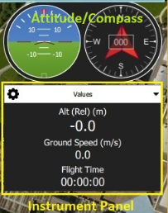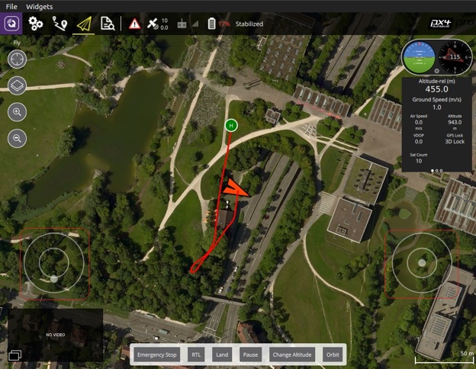

These images come in QGroundControl from Dronecode for reference only.

## The function of the mobile application

### Display real-time view from UAV

Users can watch the real-time view of the UAV on the main view by the video streaming technology when the smartphone connects to the UAV. If the connection is failed, there are black view only.

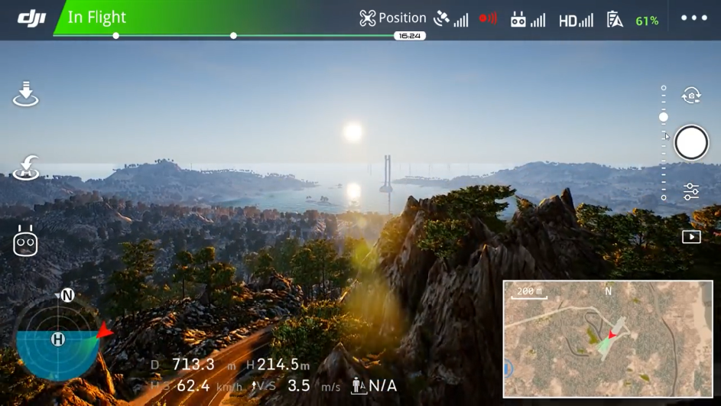

This image comes in DJI Go 4 for reference only. This show that how the real-time view display to users.

### Control UAV

Users could control the UAV by their mobile phones. The monitor will display the image captured by the camera on the UAV. Clients could control the UAV by virtual joysticks to move the UAV. The available actions include "rise", "decline", "go", "back", "turn" and "translation".

### View UAV status information

Users can watch the UAV status information on the main view. This information includes attitude, direction, altitude, speed and flight time etc.



This image comes in QGroundControl from Dronecode for reference only.

## Take photo or video

Users can take photo during live stream. Also, users can take video that the UAV control period captured view is made a video.

## The structure of the Windows application

The window application is designed on different layers. The first view is the function menu. There are two functions named "Build up mission" and "View mission". This will guide the user to another view to execute different functions. The functions will be introduced after.

## The function of the Windows application

### Build up new mission

Users can build up a new mission. The mission will keep all climatic data which the UAV will collect.

### View mission

Users can view all the missions which are user-built before. Each mission will show climatic data which the UAV collected before in this mission. Also, some data analysis diagrams are generated using these data by the system for users analyze environment.

### Data collection

The real-time data will be collected as soon as the drone is connected to the application. After connected to the drone, the collected real-time data will be shown at a specific position where it is on the same page as real-time view.

### Display real-time view from UAV

Users can watch the real-time view of the UAV on the main view by the video streaming technology when the notebook computer connects to the UAV. If the connection is failed, there are black view only.

## The inspection sensor of the drone

The system minimally requires a gyroscope, accelerometer, magnetometer (compass) and barometer. A GPS or other positioning system is needed to enable all automatic modes, and some assisted modes.

* MS5611 barometer
* U-blox M8N GLONASS/GPS/Beidou (antenna connector type MCX)

The system contains two 9DOF (degree of freedom) IMU - MPU9250 and LSM9DS1. Each of them combines a gyroscope, an accelerometer and a magnetometer in one device. IMU sensors are not only popular as a part of drone autopilot projects, but are also widely used in devices like cellphones, tablets, etc.

* MPU9250 9DOF IMU
* LSM9DS1 9DOF IMU

For Climatological data, we install below sensors:

* DHT22 Temperature-Humidity Sensor

The DHT22 is a basic, low-cost digital temperature and humidity sensor. It uses a capacitive humidity sensor and a thermistor to measure the surrounding air. It's fairly simple to use but requires careful timing to grab data. The only real downside of this sensor is you can only get new data from it once every 2 seconds, sensor readings can be up to 2 seconds old.

* MQ-2 Semiconductor Sensor for Combustible Gas Sensor

Sensitive material of MQ-2 gas sensor is SnO2, which with lower conductivity in clean air. When the target combustible gas exists, the sensor’s conductivity is higher along with the gas concentration rising. Using a simple electro circuit, convert change of conductivity to correspond output signal of gas concentration.

MQ-2 gas sensor has high sensitivity to LPG, Propane and Hydrogen, also could be used to Methane and other combustible steam, it is with low cost and suitable for different application.

* SDS011 Laser PM2.5 Sensor

The SDS011 using principle of laser scattering, can get the particle concentration between 0.3 to 10μm in the air. It with digital output and built-in fan is stable and reliable.

* UV Detection Sensor

Just a normal UV sensor.

How to make users easily to use our system

To increase the system acceptability, we will develop different prototype to test to make sure all users can use our system easily without professional knowledge. And the system will use simple English to reduce hinder when new user uses our system.

# Project Scope

By the end of the project, Automated Data Collecting System would be able to provide the following services to the users.

1. Users can control the UAV by the mobile application
2. Users can collect climatic data
3. Users can view the collected data by chart format on a mission
4. Users can take photo or video by the mobile application from the UAV

# Constraints

## Wi-Fi stability problem

For our project, we use an AWUS036NHA Wi-Fi adapter to broadcast the video and control signal. This adapter will provide around 280mW output power. Ranges of several kilometers have been reported (with directional antennas though). But the big problem is the connection problems. Sometimes, the network connect was too slow, the mobile app needs a few times to update the information to keep the data consistency.

Also, we cannot confirm the range because we do not want to take the risk to lose our device.

## Battery capacity limitation

For our project, we consider using 4s3p Samsung 30Q LiPo battery pack. This Samsung 18650 battery will provide max 3000mAh of rated discharge capacity and max 20A discharge current.

For the flight time:

**Flight times = (Battery Capacity * Battery Discharge /Average Amp Draw) * 60 minutes**

Under my calculation, this battery will provide 21.6 minutes of flight times.

## Fire risk with the LiPo battery

For our project, we use Lithium Polymer technology which allows considerable energy to be stored in a small package. But they are associated with fire risk and have been known to spontaneously catch fire while charging or if punctured. Most airlines restrict the numbers of batteries on board. Check with your airline for their policy on transporting batteries. It is recommended never to leave them unattended while charging and to transport and store them in a fireproof box.

## Weather problem

It is not recommended to fly drones in rain, snow, or even in the drizzle. Apart from any physical effects on the aircraft, there is a danger the electronics will be damaged, and communication between the controller and the drone can be affected when there is any kind of precipitation in the air.

## Hong Kong Drone Regulations

According to Hong Kong national aviation authority, the Hong Kong Civil Aviation Department (HKCAD), flying a drone is legal in Hong Kong, but they also set some rules:

**General Safety Guidelines for Flying UAS**

Any person who operates UAS shall observe the following general safety guidelines, unless otherwise permitted by CAD.

**1.Where you cannot fly**

(i)UAS shall not be flown in the vicinity of an airport and aircraft approach and take-off paths, which include:

-Areas within 5 km of Hong Kong International Airport;

-North Lantau coastal area;

-Coastal areas from Tai Lam Chung to Tsuen Wan and Tsing Yi Island;

-Victoria Harbour and its coastal areas; and

-Shek Kong area.

(ii)UAS shall not be flown over populated and congested areas.

(iii)UAS shall not be flown over, or close to, any object, installation or facility that would present a risk to safety in the event of damage due to any impact by the UAS, or in such a manner that the good order and discipline and control thereof may be or may likely be jeopardized.

**2.Good Choice of Flying Sites**

A good choice of flying site not only minimises the possibility of an accident but also enhances the pleasure of the flying experience.

Here are some tips to help you choose a good site. A good site should be:

(i)clear of persons, vessels, vehicles or structures;

(ii)away from helicopter landing pads;

(iii)clear of any power sources such as power lines, transformer stations, pylons, and transmitter towers etc., which might cause radio interference;

(iv)flat enough to enable safe take-off and landing; and

(v)free from visual obstruction, so that the operator can see the UAS in flight at all times.

**3.Altitude**

The altitude of operations shall not exceed 300 feet (~90 m) above ground level.

**4.Time of Operations**

The operations of UAS shall be conducted during daylight hours only.

**5.Weather Criteria**

(i)UAS shall only be operated under good visibility and weather conditions.

(ii)UAS shall not be operated when Rainstorm Warning, Tropical Cyclone Warning or Strong Monsoon Signal is in force.

**6.Heavy UAS**

Except with Civil Aviation Department's endorsement, heavy UAS weighing more than 7 kg (without its fuel) is not allowed to fly in Hong Kong.

**7.Control of UAS**

The UAS operator shall be on site and keep the UAS within Visual Line of Sight (VLOS) during the period of the flight. Operating within VLOS means that the UAS operator is able to maintain direct, unaided (other than corrective lenses) visual contact with the UAS, and is able to monitor the UAS flight path in relation to other aircraft, persons, vessels, vehicles and structures for the purpose of avoiding collisions.

**8.Safety Check on UAS**

The UAS operator shall perform a safety check on UAS (including its fuel or lithium batteries) before operating UAS.

# Hardware Facility

## Drone

Our UAV are all made by us, the following information show the UAV specification.

Frame: DJI F450

Flight Controller: Navio2

Motor: 2212-920KV

ESC: 20A

Propeller: 9450

Battery: 4s3p LiPo Battery

Onboard computer: Raspberry Pi 3B+

|  |  |
| --- | --- |
|  |  |
|  |  |

## Client

any modern computer or mobile device. Performance will depend on the system environment, 3rd party applications, and available system resources. More capable hardware will provide a better experience. A computer with at least 8Gb RAM, an SSD, Nvidia or AMD graphics and an i5 or better CPU will be suitable for most applications.

Support Device:

Mobile with Google Android 5.1 or later.

# Software Process Model

Agile Development

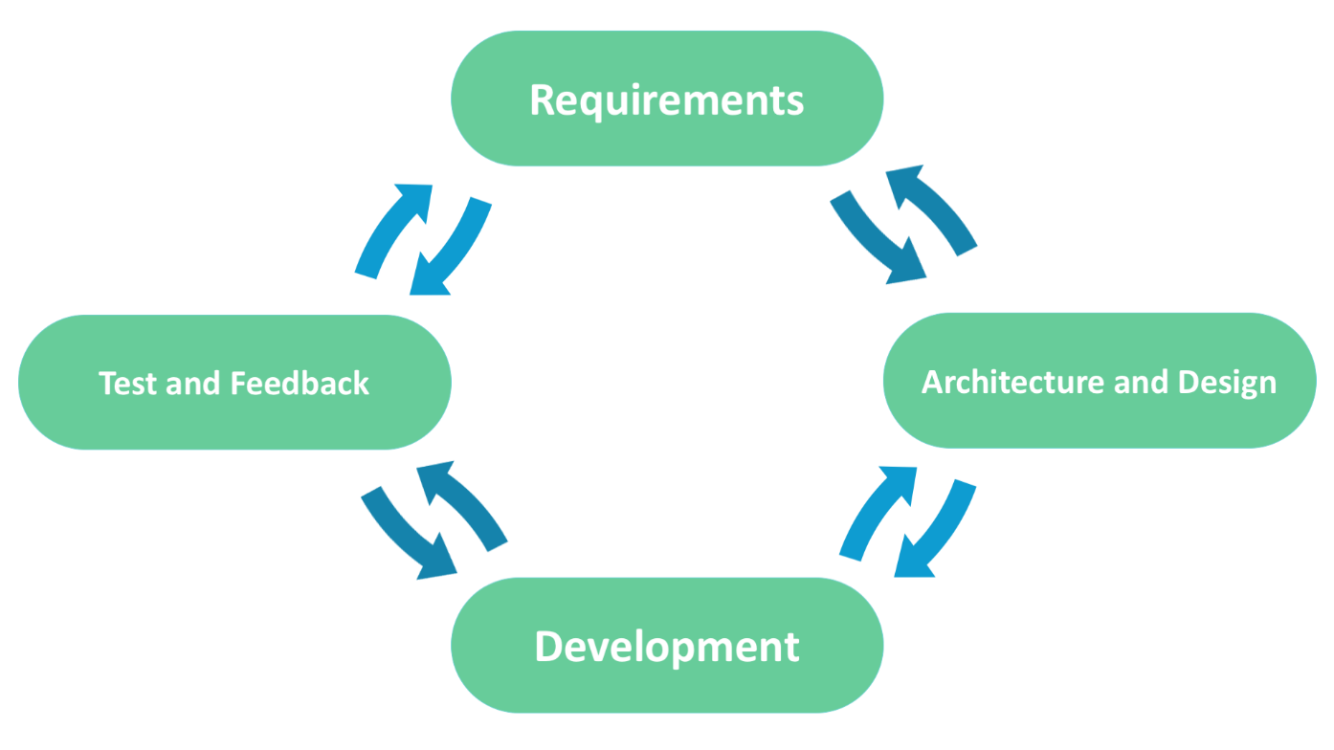

# Project Plan

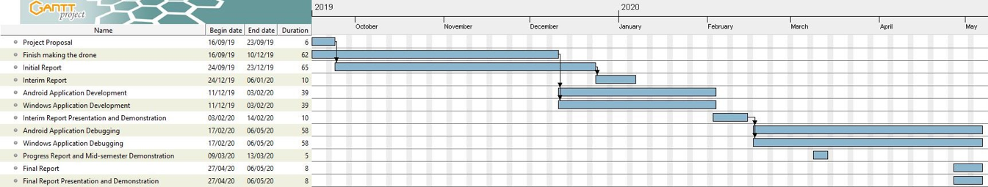

## Staffing & Responsibilities

|  |  |  |
| --- | --- | --- |
| Role | Task | Student Name |
| Leader, programmer | Leads the group, write a pc application | Wong Ming Yuen |
| Designer, programmer | Buy ingredients and design the UAV, write pc application | Siu Chi Wang |
| Programmer | Write Android application | Kwok Tsz Lung |
| Programmer | Write Android application | Chau Yat Sum |

# UML Diagrams

Initial Use Case Diagram – Android

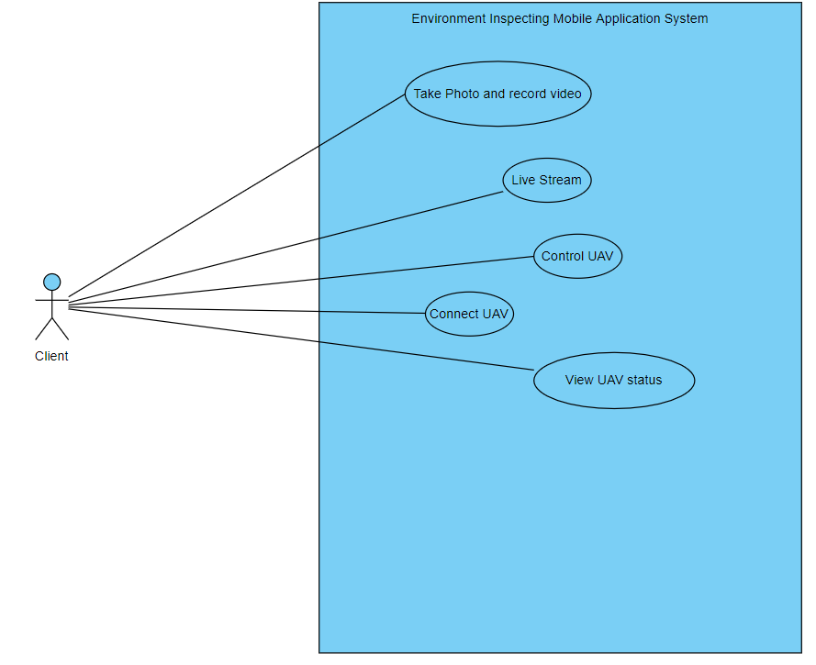

## Actor Descriptions – Mobile App

|  |  |
| --- | --- |
| Actor Name: | Client |
| Description: | Client is the end-user interacts with the system by using the mobile application. |

## Initial Use Case Descriptions – Mobile App

|  |  |
| --- | --- |
| Use case name: | Connect UAV |
| Use case ID | UC-0001 |
| Actor(s) | Client |
| Brief description: | The app will connect with the UAV through Wi-Fi connection. |

|  |  |
| --- | --- |
| Use case name: | Control UAV |
| Use case ID | UC-0002 |
| Actor(s) | Client |
| Brief description: | The app will display virtual joysticks. User could use them to control the UAV with actions include "rise", "decline", "go", "back", "turn" and "translation". |

|  |  |
| --- | --- |
| Use case name: | Live stream |
| Use case ID | UC-0003 |
| Actor(s) | Client |
| Brief description: | The app will display image captured by the camera on the UAV during controlling the UAV. |

|  |  |
| --- | --- |
| Use case name: | View UAV status |
| Use case ID | UC-0004 |
| Actor(s) | Client |
| Brief description: | The user could view the UAV status such as height from the app. |

|  |  |
| --- | --- |
| Use case name: | Take Photo and record video |
| Use case ID | UC-0005 |
| Actor(s) | Client |
| Brief description: | User could take photo during live stream. |

## Refined Use Case Diagram – Mobile App

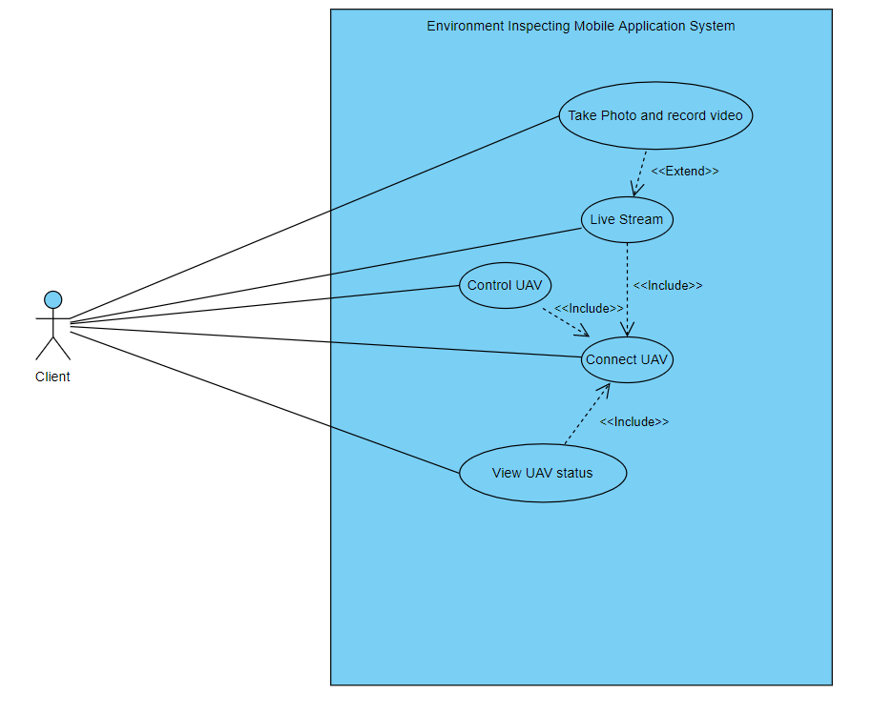

## Refined Use Case Descriptions – Mobile App

|  |  |
| --- | --- |
| Use case name: | Connect UAV |
| Use case ID: | UC-0001 |
| Actor(s): | Client |
| Brief description: | The app will connect with the UAV through Wi-Fi connection. |
| Preconditions | The mobile phone has installed the app |
| Flow of events: | 1.open the application on mobile.  2. switch on the UAV  3. Connect both the UAV and mobile to the same Wi-Fi |
| Postconditions: | ／ |
| Alternative flows and exceptions: | User had to connect the correct Wi-Fi. Otherwise, it cannot connect the UAV. |
| Non-behavior requirements: | ／ |
| Assumptions: | The user use Android devices. |

|  |  |
| --- | --- |
| Use case name: | Control UAV |
| Use case ID: | UC-0002 |
| Actor(s): | Client |
| Brief description: | The app will display virtual joysticks. User could use them to control the UAV with actions include "rise", "decline", "go", "back", "turn" and "translation". |
| Preconditions | The mobile had connected to correct and available Wi-Fi |
| Flow of events: | 1.Include (Connect UAV)  2.Control the UAV by virtual joysticks |
| Postconditions: | ／ |
| Alternative flows and exceptions: | User had to connect the correct Wi-Fi. Otherwise, it cannot control the UAV. |
| Non-behavior requirements: | ／ |
| Assumptions: | The user use Android devices. |

|  |  |
| --- | --- |
| Use case name: | Live stream |
| Use case ID: | UC-0003 |
| Actor(s): | Client |
| Brief description: | The app will display image captured by the camera on the UAV during controlling the UAV. |
| Preconditions | The mobile had connected to correct and available Wi-Fi |
| Flow of events: | 1.Include (Connect UAV)  2.switch on camera on UAV connected  3.Press view live button  4.The app display the live image. |
| Postconditions: | ／ |
| Alternative flows and exceptions: | User had to connect the correct Wi-Fi. Otherwise, it cannot view live image the UAV. |
| Non-behavior requirements: | ／ |
| Assumptions: | The user use Android devices. |

|  |  |
| --- | --- |
| Use case name: | View UAV status |
| Use case ID: | UC-0004 |
| Actor(s): | Client |
| Brief description: | The user could view the UAV status such as height from the app. |
| Preconditions | The mobile had connected to correct and available Wi-Fi |
| Flow of events: | 1.Include (Connect UAV)  2.Press view UAV status button  3.The app display current status of the UAV |
| Postconditions: | ／ |
| Alternative flows and exceptions: | User had to connect the correct Wi-Fi. Otherwise, it cannot view live image the UAV. |
| Non-behavior requirements: | ／ |
| Assumptions: | The user use Android devices. |

|  |  |
| --- | --- |
| Use case name: | Take Photo and record video |
| Use case ID: | UC-0005 |
| Actor(s): | Client |
| Brief description: | User could take photo during live stream. |
| Preconditions | The mobile had connected to correct and available Wi-Fi |
| Flow of events: | 1.Extend (Live Stream)  2.Press record video button or press camera-liked button  3.The app will capture current display as a video or photo |
| Postconditions: | ／ |
| Alternative flows and exceptions: | User had to connect the correct Wi-Fi. Otherwise, it cannot view live image the UAV. |
| Non-behavior requirements: | ／ |
| Assumptions: | The user uses Android devices. |

## Initial Use Case Diagram – Windows App

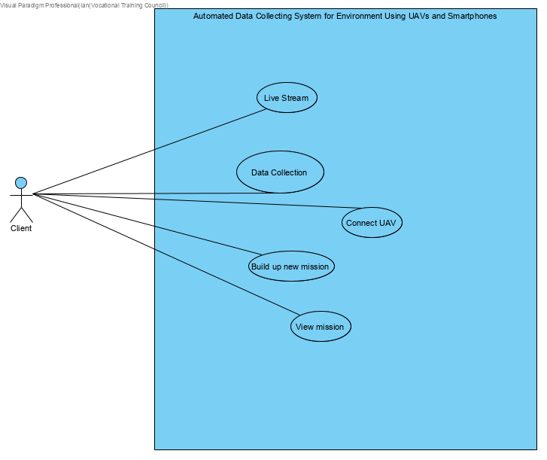

## Actor Descriptions – Windows App

|  |  |
| --- | --- |
| Actor Name: | Client |
| Description: | Client is the end-user interacts with the system by using the Windows application. |

## Initial Use Case Descriptions – Windows App

|  |  |
| --- | --- |
| Use case name: | Live Stream |
| Use case ID | UC-0001 |
| Actor(s) | Client |
| Brief description: | The app will display image captured by the camera on the UAV during controlling the UAV. |

|  |  |
| --- | --- |
| Use case name: | Data Collection |
| Use case ID | UC-0002 |
| Actor(s) | Client |
| Brief description: | Collected data will be displayed at a specific position on the same page as real-time view. |

|  |  |
| --- | --- |
| Use case name: | Connect UAV |
| Use case ID | UC-0003 |
| Actor(s) | Client |
| Brief description: | The app will connect with the UAV through Wi-Fi connection. |

|  |  |
| --- | --- |
| Use case name: | Build Up New Mission |
| Use case ID | UC-0004 |
| Actor(s) | Client |
| Brief description: | The client can build up a mission to keep all collected climatic data by the UAV. |

|  |  |
| --- | --- |
| Use case name: | View Mission |
| Use case ID | UC-0005 |
| Actor(s) | Client |
| Brief description: | The client can check the collected climatic data by looking at the previous missions. |

## Refined Use Case Diagram – Windows App

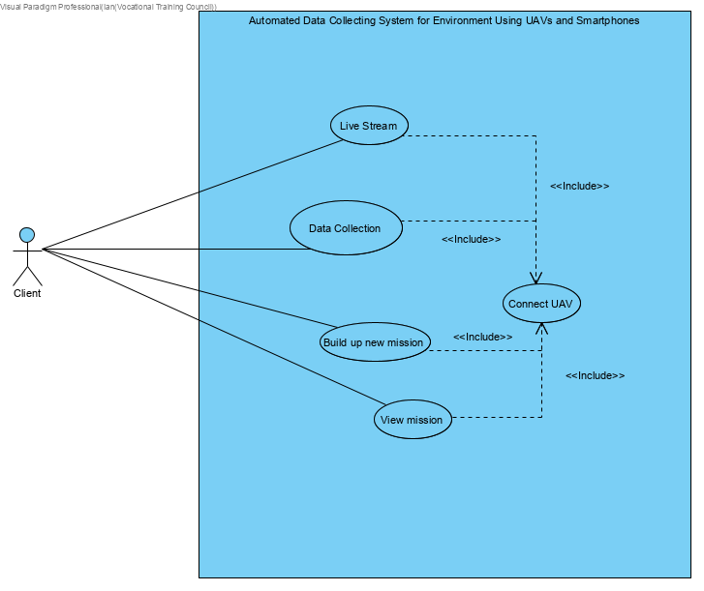

## Refined Use Case Descriptions – Windows App

|  |  |
| --- | --- |
| Use case name: | Connect UAV |
| Use case ID: | UC-0001 |
| Actor(s): | Client |
| Brief description: | The app will connect with the UAV through Wi-Fi connection. |
| Preconditions | The notebook computer has installed the app |
| Flow of events: | 1.open the application in the notebook computer.  2. switch on the UAV  3. Connect both the UAV and notebook computer to the same Wi-Fi |
| Postconditions: | ／ |
| Alternative flows and exceptions: | User had to connect the correct Wi-Fi. Otherwise, it cannot connect the UAV. |
| Non-behavior requirements: | ／ |
| Assumptions: | The user uses Windows computer devices. |

|  |  |
| --- | --- |
| Use case name: | Live stream |
| Use case ID: | UC-0002 |
| Actor(s): | Client |
| Brief description: | The app will display real-time streaming captured by the camera on the UAV during controlling the UAV. |
| Preconditions | The notebook computer had connected to correct and available Wi-Fi |
| Flow of events: | 1.Include (Connect UAV)  2.switch on camera on UAV connected  3.Press view live button  4.The app displays the live image. |
| Postconditions: | ／ |
| Alternative flows and exceptions: | User had to connect the correct Wi-Fi. Otherwise, it cannot view live image the UAV. |
| Non-behavior requirements: | ／ |
| Assumptions: | The user uses Windows computer devices. |

|  |  |
| --- | --- |
| Use case name: | Data Collection |
| Use case ID: | UC-0003 |
| Actor(s): | Client |
| Brief description: | The real-time climatic data will be collected and shown at a specific position on the screen. |
| Preconditions | The notebook computer had connected to correct and available Wi-Fi |
| Flow of events: | 1.Include (Connect UAV)  2.switch on the UAV and connects it to the notebook computer  3.Real-time climatic data will be collected and display in the set position immediately after successfully connected both computer and UAV |
| Postconditions: | ／ |
| Alternative flows and exceptions: | User had to connect the correct Wi-Fi. Otherwise, it cannot view live image the UAV. |
| Non-behavior requirements: | ／ |
| Assumptions: | The user uses Windows computer devices. |

|  |  |
| --- | --- |
| Use case name: | Build up new mission |
| Use case ID: | UC-0004 |
| Actor(s): | Client |
| Brief description: | The app will store real-time data on the UAV during connection to the UAV. |
| Preconditions | The notebook computer had connected to correct and available Wi-Fi |
| Flow of events: | 1.Include (Connect UAV)  2.switch on the UAV and connects it to the notebook computer  3.Press “build up new mission” button  4.A new mission will be built. |
| Postconditions: | ／ |
| Alternative flows and exceptions: | User had to connect the correct Wi-Fi. Otherwise, it cannot view live image the UAV. |
| Non-behavior requirements: | ／ |
| Assumptions: | The user uses Windows computer devices. |

|  |  |
| --- | --- |
| Use case name: | View mission |
| Use case ID: | UC-0005 |
| Actor(s): | Client |
| Brief description: | "View mission” can let user check the real-time data it collected. |
| Preconditions | The notebook computer had connected to correct and available Wi-Fi |
| Flow of events: | 1.Include (Connect UAV)  2.switch on the UAV and connects it to the notebook computer  3.Press “View mission” button  4.The user can now check the previous missions and the collected data. |
| Postconditions: | ／ |
| Alternative flows and exceptions: | User had to connect the correct Wi-Fi. Otherwise, it cannot view live image the UAV. |
| Non-behavior requirements: | ／ |
| Assumptions: | The user uses Windows computer devices. |

# Reference

DJI

<https://www.dji.com/hk-en>

Dronecode

<https://www.dronecode.org/>

Samsung Introduction of INR18650-30Q

<https://eu.nkon.nl/sk/k/30q.pdf>

General Safety Guidelines for Flying UAS

<https://www.cad.gov.hk/english/UAS_safetyguidelines.html>

**End of report**